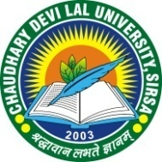
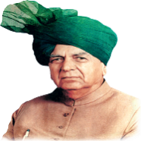
CHAUDHARY DEVI LAL UNIVERSITY, SIRSA.
(Established by the Haryana State Legislature Act, 9 of 2003)
NAAC Accredited

13th TRIVENI YUVA MAHOTSAV-2026
Theme – “युवा उमंग, संस्कृति के संग”

Annexure-I
Team Registration Form
Name of the College: …………………………………………………………………………………………..
Category | Male | Female | Total
Student participants
Accompanists (Students + Professionals)
Team Manager / Contingent In-Charges
Total composition of contingent

- Name of Team Manager:……………………………….. ……… M.Phone No……………………………
E-mail ID……………………………………………
- Name of Incharge Stage-I:……………………………………….. M.Phone No……………………………
- Name of Incharge Stage-II:……………………………………. M.Phone No……………………………
- Name of Incharge Stage-III:…………………………………… M.Phone No……………………………
- Name of Incharge Stage-IV:…………………………………… M.Phone No……………………………
Certified that all the above members have gone through the rules and have sent entries of my College/UTD for the University Youth Festival as per University Youth Festival Rules.

Date :________________ Principal/Director/Cultural Coordinator
(Office Seal)

Important: Please mail/email a copy of this complete form to dyw@cdlu.ac.in on or before 16th October, 2026.

